Repot Title Goes Here Lorem Ipsum Dolor Consect Amet

Report Subtitle Goes Here

Prepared by: Joe Bloggs | 24 April 2024

@Copyright 2024 Version 1 – All Rights Reserved

Company Classification: XXXX

PLACEHOLDER DELETE BOX &

ADD CLIENT LOGO HERE

Contents

1.1. Heading 1 3

1.1.1. Subheading 2 3

1.1.2. Subheading 3 3

1.1.3. Subheading 4 3

2. NUMBERLESS SECTION Main Heading 5

2.1. Numberless Heading 1 5

2.2. Numberless Subheading 2 5

2.3. Numberless Subheading 3 5

2.3.1. Numberless Subheading 4 5

2.3.2. Numberless Subheading 5 5

3. Main Heading 6

3.1. Pie Chart 6

3.2. Bar Chart Title 6

3.3. Smart Art Graphic 1 7

3.4. Smart Art Graphic 2 7

3. Smart Art Graphic 3 8

Version Control

|  |  |  |  |
| --- | --- | --- | --- |
| Date | Version | Changed By | Reason for Change |
|  |  |  |  |
|  |  |  |  |

Circulation List

|  |  |
| --- | --- |
| Name | Organisation/Title |
|  |  |
|  |  |

Reference Documents

|  |  |  |
| --- | --- | --- |
| Title | Description | Owner |
|  |  |  |
|  |  |  |

# Introduction

This document details the results of the <Version> Quarterly Update Testing. As per Oracle’s timetable for quarterly releases for wave <number>, the upgrade took place on non-production environments on the <day(dd/mm/yy)>, and into the production environment on the <day (dd/mm/yy)>.

## Purpose

The purpose of this document is to provide details of the testing performed during the <Version> Quarterly Update testing window, defects introduced by the updates, resolution details, and any lessons learned.

The document provides;  
• Scope of the testing  
• The processes and tools used during testing  
• Test execution Summary  
• Defect Summary (at test completion)  
• Details of any active defects (at test completion) and action plans to resolve  
• Lessons learned

# Scope

The scope of functional regression testing was approved by <Client Name> key stakeholders. The golden thread suite of tests, based on key business processes was used, with the addition of further tests identified from the impact assessment of changes, new functionality and fixes documented by Oracle. As agreed - only mandatory changes were taken with the release. Non-mandatory changes will be reviewed and collated into a roadmap.

## Test Scenarios

The testing window lasted <duration>> as prescribed by Oracle’s quarterly patching process. Testing was performed by members of Version 1, supported by <Client Name> and managed via Azure Dev Ops. Any failed tests were linked to associated defects, which were managed by Version 1. Test evidence was captured by testers during test execution and stored in Dev Ops with the test itself.

### Scenario Scope (Regression and Targeted Tests)

|  |  |  |
| --- | --- | --- |
| Test Id | Test Name | Test Area |
| AP.1 | AP.1 Check Standard Invoices and Credit Notes | AP |
| AP.2 | AP.2 testFetch | AP |
| AP.3 | AP.3 Raise Sundry Invoice Manually | AP |
| AP.5 | AP.5 Create Standard Credit Memo | AP |
| AP.6 | AP.6 Cancel an Accounted Invoice | AP |
| AP.7 | AP.7 Create Standard Invoice and Charge GB VAT | AP |
| AP.8 | AP.8 Create Standard Invoice and Charge GB Zero VAT rate | AP |
| AP.10 | AP.10 Manually Create BACS Payment | AP |
| AP.9 | AP.9 Void Payment | AP |
| AP.11 | AP.11 Manually Create Cheque Payment | AP |
| AP.12 | AP.12 Create Standard Payment Process and Pay Invoices | AP |
| AR.12a | AR.12a Create a Receipt | AR |
| AR.1 | AR.1 Create invoice Manually | AR |
| AR.2 | AR.2 Create Standalone Credit Memo | AR |
| AR.9 | AR.9 Create Customer | AR |
| AR.4 | AR.4 Credit a Transaction | AR |
| AR.6 | AR.6 Review Customer Account Balances | AR |
| AR.7 | AR.7 Manage Invoices | AR |
| AR.8 | AR.8 Manage Receipts | AR |
| AR.3 | AR.3 Perfrom Customer Search | AR |
| AR.10 | AR.10 Check Customer Autonumbering | AR |
| AR.11 | AR.11 Update Customer Details | AR |
| AR.12 | AR.12 Reverse Receipt | AR |
| AR.13 | AR.13 Create invoice with DD Receipt Method | AR |
| AR.14 | AR.14 Transfer to GL | AR |
| AR.15 | AR.15 Send Statement | AR |
| GL.1 | GL.1 Create Manual Journal - Primary Ledger in Functional Currency | GL |
| GL.2a | GL.2a Approve Journal Approval Request from WF notification | GL |
| GL.2b | GL.2b Journal Posting | GL |
| GL.3 | GL.3 Review Journals after approved | GL |
| GL.4 | GL.4 Verify journals transferred from subledgers | GL |
| GL.5 | GL.5 Inquire On Journal Balances | GL |
| PO.3A | PO.3A Search Requisition by requisition number | PO |
| PO.4A | PO.4A Create Catalog Requisition | PO |
| PO.5 | PO.5 Approve Requisition | PO |
| PO.8A | PO.8A Duplicate a purchase Requisition | PO |
| PO.9A | PO.9A Withdraw and edit Requisition | PO |
| PO.10A | PO.10A Cancel Requisition | PO |
| PO.11A | PO.11A Requesting Non Catlog Request | PO |
| PO.12A | PO.12A Approve non catalog Requisition | PO |
| PO.13A | PO.13A Edit Purchase Order | PO |
| PO.14A | PO.14A close Purchase Order | PO |
| PO.15A | PO.15A Reopen a purchase order | PO |
| PO.19A | PO.19A Return PO | PO |
| PO.16A | PO.16A Hold, Freeze Purchase Order | PO |
| PO.17A | PO.17A Process Requisition to Purchase Order | PO |
| PO.19B | PO.19B Correct Receipt | PO |
| PO.19C | PO.19C Return Receipt | PO |

# Test Overview

This section provides summary details of the tests that were performed in each module/area, defects identified and what was and wasn’t met in relation to planned entry and exit criteria.

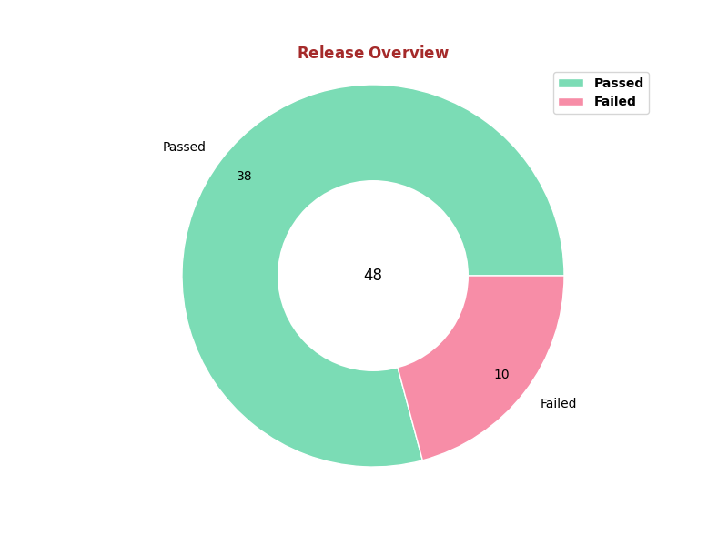

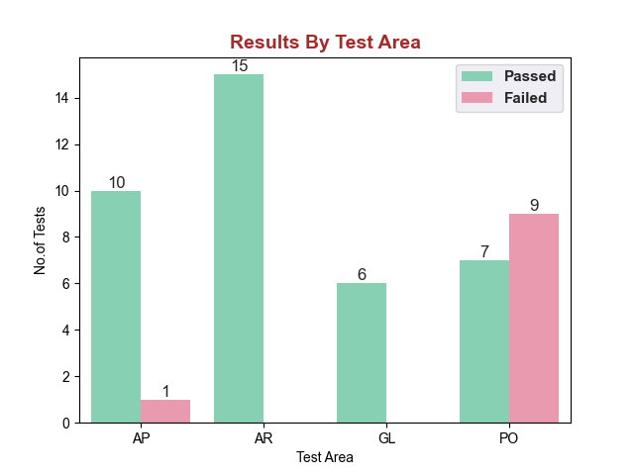

Based on the provided CSV data and focusing on count generation for each module here's a comprehensive summary:  
  
1. Total Number of Tests:  
 * Total Tests Conducted:48  
  
2. Number of Tests Passed and Failed:  
 * Passed:38  
 * Failed:10  
  
3. Breakdown by Test Area with Pass Rates:  
PO: 16 tests (7 Passed, 9 Failed) - Pass Rate: 43.75%  
AR: 15 tests (15 Passed, 0 Failed) - Pass Rate: 100.00%  
AP: 11 tests (10 Passed, 1 Failed) - Pass Rate: 90.91%  
GL: 6 tests (6 Passed, 0 Failed) - Pass Rate: 100.00%

Analyzing the provided data, here are the insights based on the specified criteria:  
  
### Most Common Error Message  
The most common error message appears to be related to a timeout exception while waiting for the presence of an element, detailed as follows:  
- **Error Message:** `org.openqa.selenium.TimeoutException: Expected condition failed: waiting for presence of element located by: By.xpath: [...] (tried for 120 second(s) with 500 milliseconds interval)`  
  
### Most Common Error Reason  
The most common error reason from the "reasons" column is:  
- **Error Reason:** `The maximum timeout was reached and the element could not be found.`  
  
### List of Failed Steps  
From the data, the failed steps are as follows:  
- I click PO number in requisition page  
- I click searched PR number in manage requisitions  
- I enter the reason in cancel requisition popup on the requisitions page  
- I enter reason in close document popup in purchase order page  
- I click on the searched purchase order on the receive items page  
- I select requisition from the list on process requisition page  
  
### Insights by Test Area:  
  
#### Test Area: AP  
- **Failed Test:** AP.2 testFetch  
- **Failed Test Reason:** The maximum timeout was reached and the element could not be found.  
- **Failed Step Reason:** N/A (No specific step mentioned)  
- **Common Error Messages:** TimeoutException related to waiting for presence of element located by a specific XPath.  
- **Common Error Reason:** The maximum timeout was reached and the element could not be found.  
  
#### Test Area: PO  
- **Failed Tests:** PO.5 Approve Requisition, PO.8A Duplicate a purchase Requisition, PO.9A Withdraw and edit Requisition, PO.10A Cancel Requisition, PO.12A Approve non catalog Requisition, PO.15A Reopen a purchase order, PO.19A Return PO, PO.16A Hold, Freeze Purchase Order, PO.17A Process Requisition to Purchase Order  
- **Failed Test Reason:** The maximum timeout was reached and the element could not be found.  
- **Failed Step Reasons:**   
 - I click PO number in requisition page  
 - I click searched PR number in manage requisitions  
 - I enter the reason in cancel requisition popup on the requisitions page  
 - I enter reason in close document popup in purchase order page  
 - I click on the searched purchase order on the receive items page  
 - I select requisition from the list on process requisition page  
- **Common Error Messages:** TimeoutException related to waiting for presence of elements located by specific XPaths.  
- **Common Error Reason:** The maximum timeout was reached and the element could not be found.  
  
#### Test Area: GL, AR  
For the test areas GL (General Ledger) and AR (Accounts Receivable), there were no failed tests or error messages detailed in the provided data, hence no specific insights related to errors or failure reasons can be provided for these areas.  
  
This analysis provides a detailed overview based on the error messages, reasons, and failed steps, offering insights into common issues encountered within each test area, notably highlighting issues related to element locators and timeouts in automated tests.

## Tests not executed

|  |  |  |  |  |
| --- | --- | --- | --- | --- |
| Test Id | Test Name | Failed Step | Reasons | Error Message |
| AP.2 | AP.2 testFetch |  | The maximum timeout was reached and the element could not be found. | org.openqa.selenium.TimeoutException: Expected condition failed: waiting for presence of element located by: By.xpath: //*[@id="pt1:_UISatr:0:lv4:0:cb2"] (tried for 120 second(s) with 500 milliseconds interval) |
| PO.5 | PO.5 Approve Requisition |  | The maximum timeout was reached and the element could not be found. | org.openqa.selenium.TimeoutException: Expected condition failed: waiting for presence of element located by: By.xpath: //*[@id="pt1:_UISatr:0:lv4:0:cb2"] (tried for 120 second(s) with 500 milliseconds interval) |
| PO.8A | PO.8A Duplicate a purchase Requisition | I click PO number in requisition page | The maximum timeout was reached and the element could not be found. | org.openqa.selenium.TimeoutException: Expected condition failed: waiting for presence of element located by: By.xpath: //*[@id="_FOpt1:_FOr1:0:_FONSr2:0:MAnt2:1:pt1:r1:0:AP1:ReqLinesAppTable:_ATp:t2:0:commandLink6"] (tried for 120 second(s) with 500 milliseconds interval) |
| PO.9A | PO.9A Withdraw and edit Requisition | I click searched PR number in manage requisitions | The maximum timeout was reached and the element could not be found. | org.openqa.selenium.TimeoutException: Expected condition failed: waiting for presence of element located by: By.xpath: //div[@id="_FOpt1:_FOr1:0:_FONSr2:0:MAnt2:1:pt1:r1:0:ap1:r1:0:allMyReqsVCResult:_ATp:t1::db"]/table/tbody/tr/td[2]/div/table/tbody/tr/td[1] (tried for 120 second(s) with 500 milliseconds interval) |
| PO.10A | PO.10A Cancel Requisition | I enter the reason in cancel requisition popup on the requisitions page | The maximum timeout was reached and the element could not be found. | org.openqa.selenium.TimeoutException: Expected condition failed: waiting for presence of element located by: By.xpath: //textarea[@id="_FOpt1:_FOr1:0:_FONSr2:0:MAnt2:1:pt1:r1:0:ap1:r1:0:it1::content"] (tried for 120 second(s) with 500 milliseconds interval) |
| PO.12A | PO.12A Approve non catalog Requisition |  | The maximum timeout was reached and the element could not be found. | org.openqa.selenium.TimeoutException: Expected condition failed: waiting for presence of element located by: By.xpath: //*[@id="pt1:_UISatr:0:lv4:0:cb2"] (tried for 120 second(s) with 500 milliseconds interval) |
| PO.15A | PO.15A Reopen a purchase order | I enter reason in close document popup in purchase order page | The maximum timeout was reached and the element could not be found. | org.openqa.selenium.TimeoutException: Expected condition failed: waiting for presence of element located by: By.xpath: //textarea[@id='_FOpt1:_FOr1:0:_FONSr2:0:MAt3:0:pt1:viewl1:0:AP2:it4::content'] (tried for 120 second(s) with 500 milliseconds interval) |
| PO.19A | PO.19A Return PO | I click on the searched purchase order on the receive items page | The maximum timeout was reached and the element could not be found. | org.openqa.selenium.TimeoutException: Expected condition failed: waiting for presence of element located by: By.xpath: //div[@id="_FOpt1:_FOr1:0:_FONSr2:0:_FOTsr1:0:ap1:AT1:_ATp:QrRsId::db"]/table/tbody/tr/td[2]/div/table/tbody/tr/td[1] (tried for 120 second(s) with 500 milliseconds interval) |
| PO.16A | PO.16A Hold, Freeze Purchase Order | I enter reason in close document popup in purchase order page | The maximum timeout was reached and the element could not be found. | org.openqa.selenium.TimeoutException: Expected condition failed: waiting for presence of element located by: By.xpath: //textarea[@id='_FOpt1:_FOr1:0:_FONSr2:0:MAt3:0:pt1:viewl1:0:AP2:it4::content'] (tried for 120 second(s) with 500 milliseconds interval) |
| PO.17A | PO.17A Process Requisition to Purchase Order | I select requisition from the list on process requistion page | The maximum timeout was reached and the element could not be found. | org.openqa.selenium.TimeoutException: Expected condition failed: waiting for presence of element located by: By.xpath: //div[@id="_FOpt1:_FOr1:0:_FONSr2:0:MAt2:0:pt1:r1:0:AP1:AT5:_ATp:srchTab::db"]/table/tbody/tr/td[1] (tried for 120 second(s) with 500 milliseconds interval) |

## Tools and processes

The testing window lasted <duration>> as prescribed by Oracle’s quarterly patching process. Testing was performed by members of Version 1, supported by <Client Name> and managed via Azure Dev Ops. Any failed tests were linked to associated defects, which were managed by Version 1. Test evidence was captured by testers during test execution and stored in Dev Ops with the test itself.

## Environment set up and testing approach

As discussed and agreed at the planning stage the bulk of the functional and integration testing was carried out in the environments below (last refresh from PROD date <dd/mm/yy>).

|  |  |  |  |
| --- | --- | --- | --- |
| **Env Name** | **Config Requirements** | **Start** | **End** |
|  |  |  |  |
|  |  |  |  |
|  |  |  |  |

## Test execution entry criteria

The following entry criteria was agreed.

|  |  |  |
| --- | --- | --- |
| **Criteria** | **Met / not met** | **Mitigation factors (if not met)** |
|  |  |  |
|  |  |  |

## Test execution exit criteria

The following entry criteria was agreed.

|  |  |  |
| --- | --- | --- |
| **Criteria** | **Met / not met** | **Mitigation factors (if not met)** |
|  |  |  |
|  |  |  |

## Evidence of Regression Test Completion

### Functional testing

All functional testing across the agreed scope of modules was tracked in Azure Dev Ops via summary dashboards. Test evidence can be found in Azure Dev Ops.

# Defects

All functional testing across the agreed scope of modules was tracked in Azure Dev Ops via summary dashboards. Test evidence can be found in Azure Dev Ops.

## Failed tests

|  |  |  |  |  |
| --- | --- | --- | --- | --- |
| **ID** | **Title** | **Module / Area** | **Status** | **Comment** |
|  |  |  |  |  |
|  |  |  |  |  |

## Defect Status Summary

|  |  |  |  |
| --- | --- | --- | --- |
| **Azure DevOps Bug Number** | **Title** | **Defect Status** | **Resolution** |
|  |  |  |  |
|  |  |  |  |
|  |  |  |  |

# Communications

It was agreed with <Client Name> that they would update any documentation necessary to reflect the changes introduced with the release.

# Lessons Learned

## Issues and Recommended Actions

|  |  |  |
| --- | --- | --- |
| **Issue** | **Proposed Action** | **Owner** |
|  |  |  |
|  |  |  |